**Create Nest Product with Nest Developer Account**

**Overview:**

In prior versions of NST Manager, the Token that was used for authenticating NST Manager to Nest was an automated process that took place from within the NST Manager SmartApp. This process has now changed and requires the end user (you) to generate their own token by creating a Developer Account on Nest (this is free) and creating a New Product that will allow you to insert the information from this Product into the NST Manager SmartApp.

Contents

Creating your Nest Developer Account 2

Creating a New Product 2

Filling out the Product Information (Part 1): 3

Selecting Permissions (Part 2): 4

Product ID / Product Secret: 7

Copy / Paste to NST Manager: 8

# Creating your Nest Developer Account

* Go to [Nest Developer Portal](https://developers.nest.com/) and create a new account (*If you don't have one!*)

# Creating a New Product

1. Click on Create New Product.



1. The following screen will be displayed:

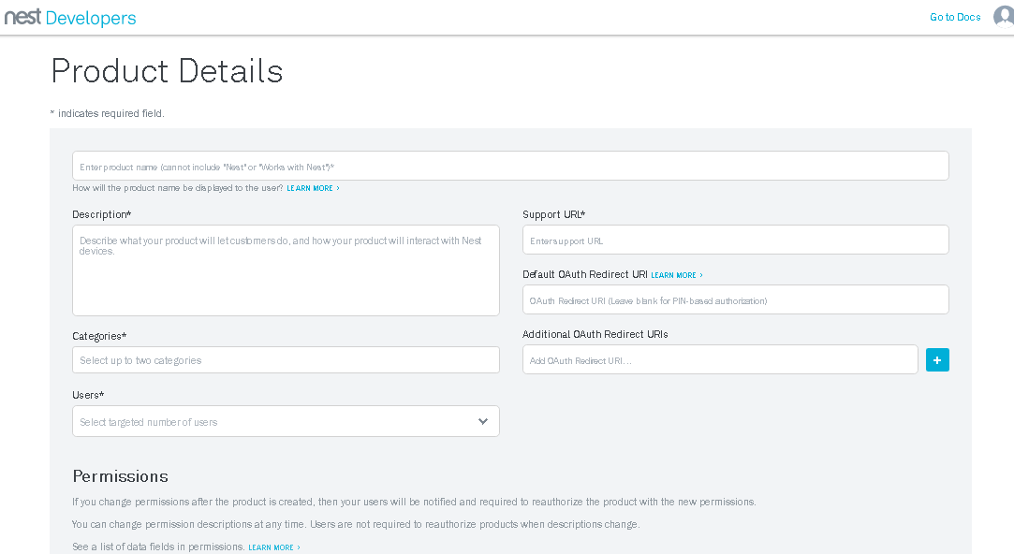

## Filling out the Product Information (Part 1):

1. **Product Name:**

* Enter any unique name for your product (This name will be displayed in the Nest Application under “Works With Nest” in Settings.
* If you see the “**Name already in use**”, keep typing and give the product name something unique. The red text will disappear when your name is unique.

1. **Description*:**

* Copy / Paste the following text:

NST Manager allows you to integrate your Nest products with the SmartThings platform. It can be used to trigger or respond to various device events by using standard SmartThings capabilities. This allows for a high level customization of automations.

1. **Categories*:**

* Select the following Categories (you select each one individually)
  + 1. HVAC
    2. Home Automation

1. **Users*:**

* Select Individual

1. **Support URL*:**

* Copy / Paste the following URL:

<https://community.smartthings.com/t/release-nest-manager-v5-0/83228>

1. **Default OAuth Redirect URL:**

* Copy / Paste the following URL:

<https://graph.api.smartthings.com/oauth/callback>

**Note:** Verify that you didn’t accidentally copy / paste the URL with any leading or trailing spaces. Your authentication will fail otherwise.

1. **Additional OAuth Redirect URIs (Not Required)**

* Leave this field blank

## Selecting Permissions (Part 2):

**Note:** There are 8 Permissions that must be selected and set to Read or Read/Write in order for the NST Manager to function appropriately with your Nest Products.

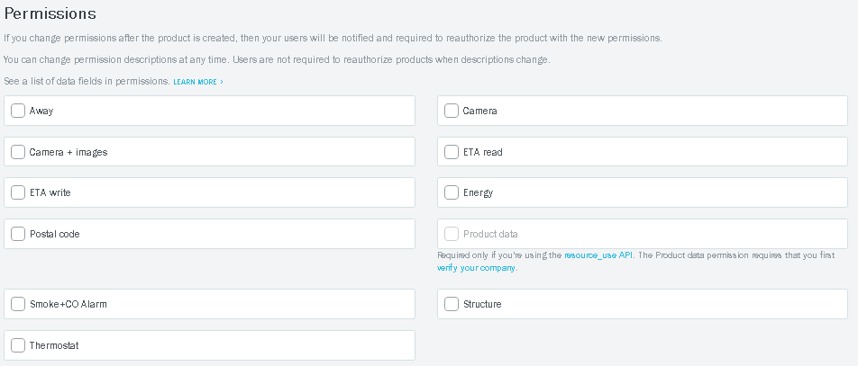

**Select the following permissions with the appropriate capability and copy / paste the description text**

**Away**

* read/write v2
* Description to copy / paste:

NST Manager use SmartThings (Presence, Mode, or Switches) to change your Nest's Home/Away status.

**Camera + Images**

* read/write v4
* Description to copy / paste:

NST Manager uses many combinations of SmartThings device events to turn your Nest Camera on/off.

**Postal Code**

* read v2
* Description to copy / paste:

NST Manager uses your postal code when we are unable to determine your SmartThings location info.

**Smoke + CO Alarm**

* read v5
* Description to copy / paste:

NST Manager can trigger delayed alerts in SmartThings Platform that can perform tasks based on the alarm type.

**Thermostat**

* read/write v6
* Description to copy / paste:

NST Manager can trigger actions in SmartThings when a temperature, humidity, HVAC mode events occurs.

**ETA Write**

* write v2
* Description to copy / paste:

NST Manager can allow you to begin warm ups if your one your way home.

**ETA Read**

* read v1
* Description to copy / paste:

NST Manager can use the ETA data to view it's current status.

**Security State**

* read v1
* Description to copy / paste:

Allow NST Manager to view the locations Security State (if available)

**When completed, the 8 Permissions you selected should match the following:**

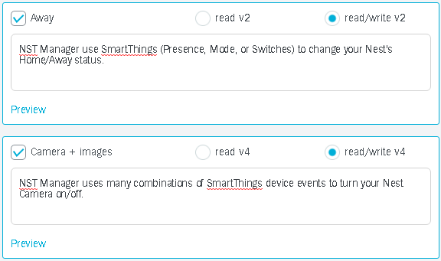

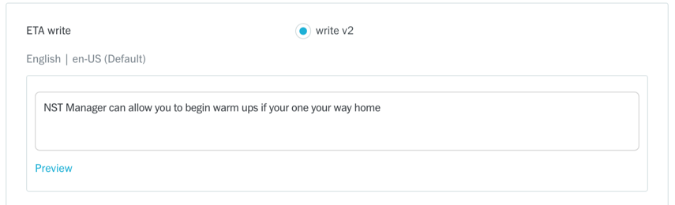

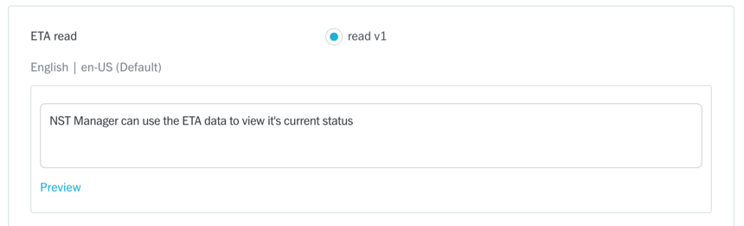

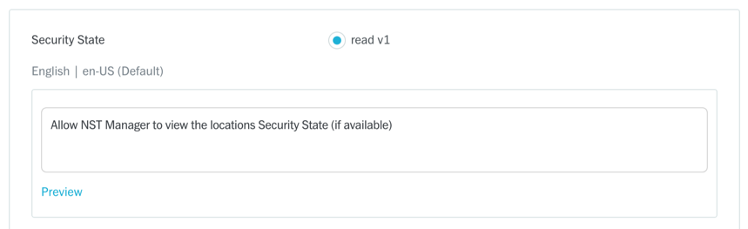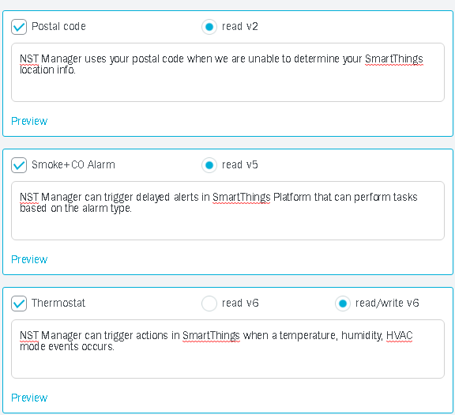

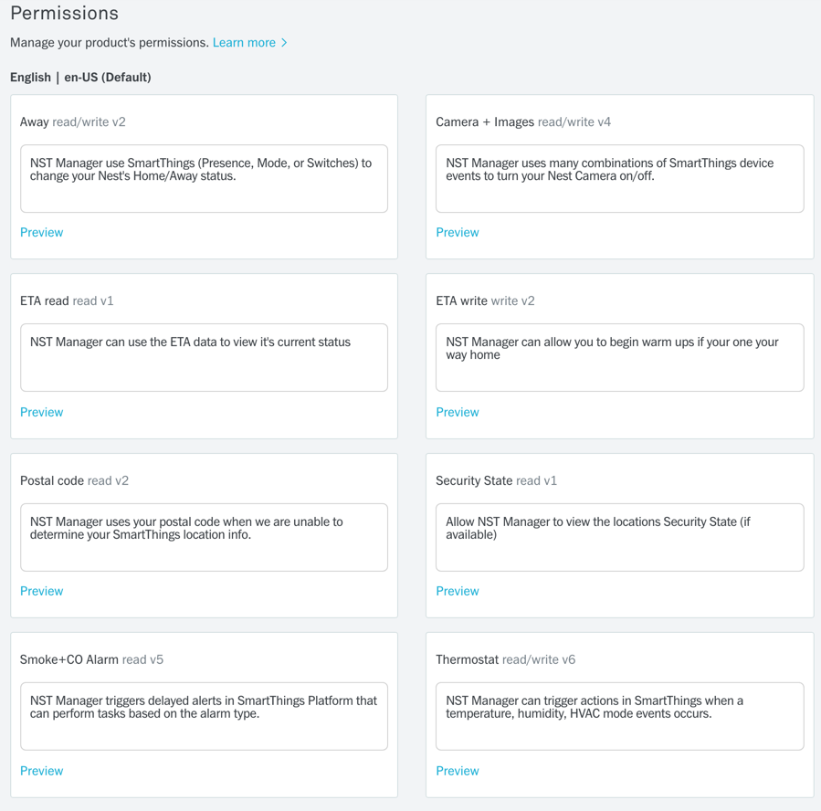

**After you have completed and verified all of the above, you can proceed by pressing the Create Product button:**



# 

# Product ID / Product Secret:

Upon successful creation of your product, you will automatically be taken to the Overview screen:

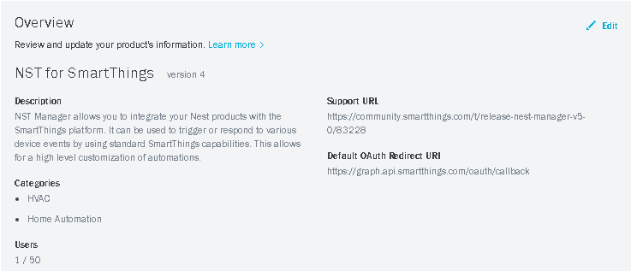

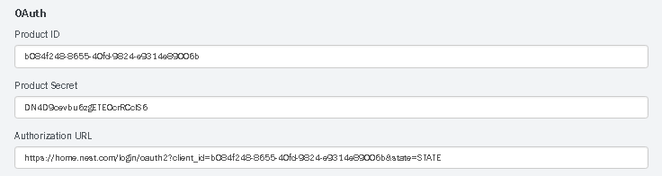

## Copy / Paste to NST Manager:

* 1. The Product ID and Product Secret above will need to be copied / pasted into the NST Manager SmartApp via IDE.
  2. Login to IDE for SmartThings (You should already know how to do this as you have added the NST Manager SmartApp using this method already).
  3. After logging in to IDE, select SmartApps and then press on the  icon on the left side next to NST Manager
  4. Scroll down and select Settings:

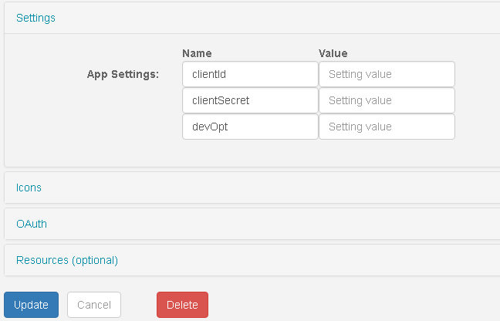

* 1. You will copy and paste the following fields from your Nest Developer Overview Console into the settings above in NST Manager IDE:
     + Product ID 🡪 clientID
     + Product Secret 🡪 clientSecret

Notes:

* + - When copying / pasting the above, verify that you do not have leading or trailing spaces in the fields above. Authentication will fail otherwise.
    - Do not share this information with anyone as it is unique to you and your products)
  1. Press the Update button

If you have not yet, installed NST Manager from the Market Place in the SmartThings Mobile Application, you may proceed with those steps now. For those of you that have already previously installed NST Manager, you can open the NST Manager from Automation / SmartApps and follow the instructions on resetting your existing token.